

ALI RAZA
BSCS (A)
9864
DBMS LAB

LAB NO 02

Exercise no 01:

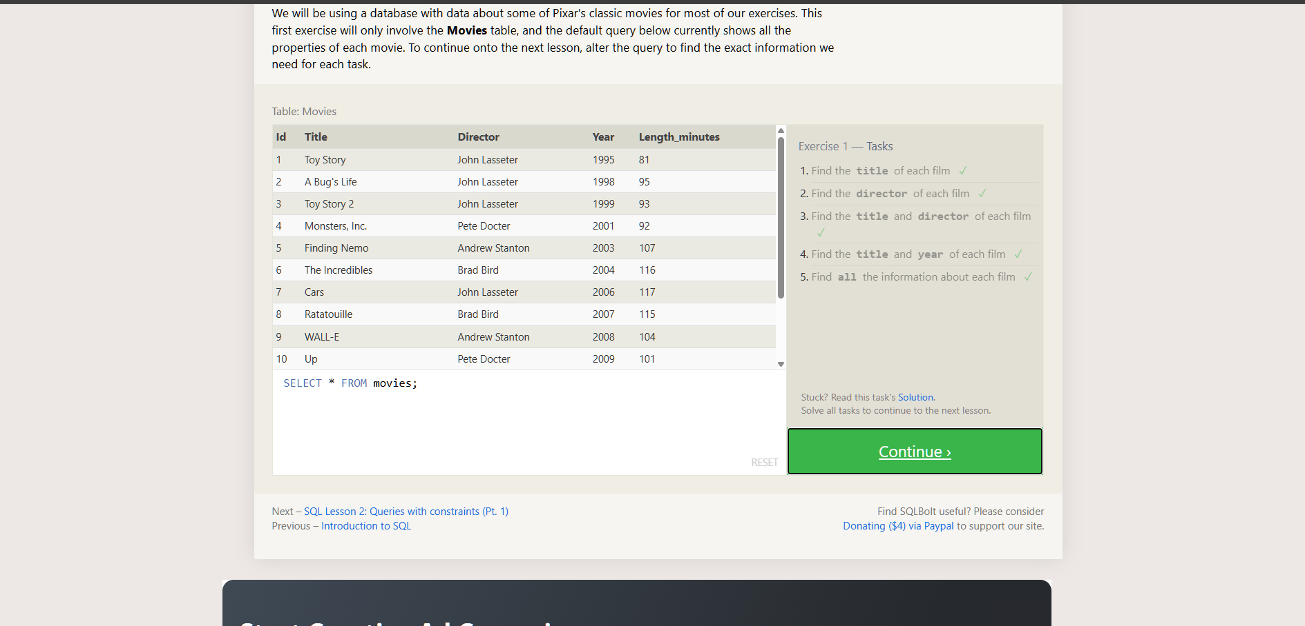

Exercise no 02:
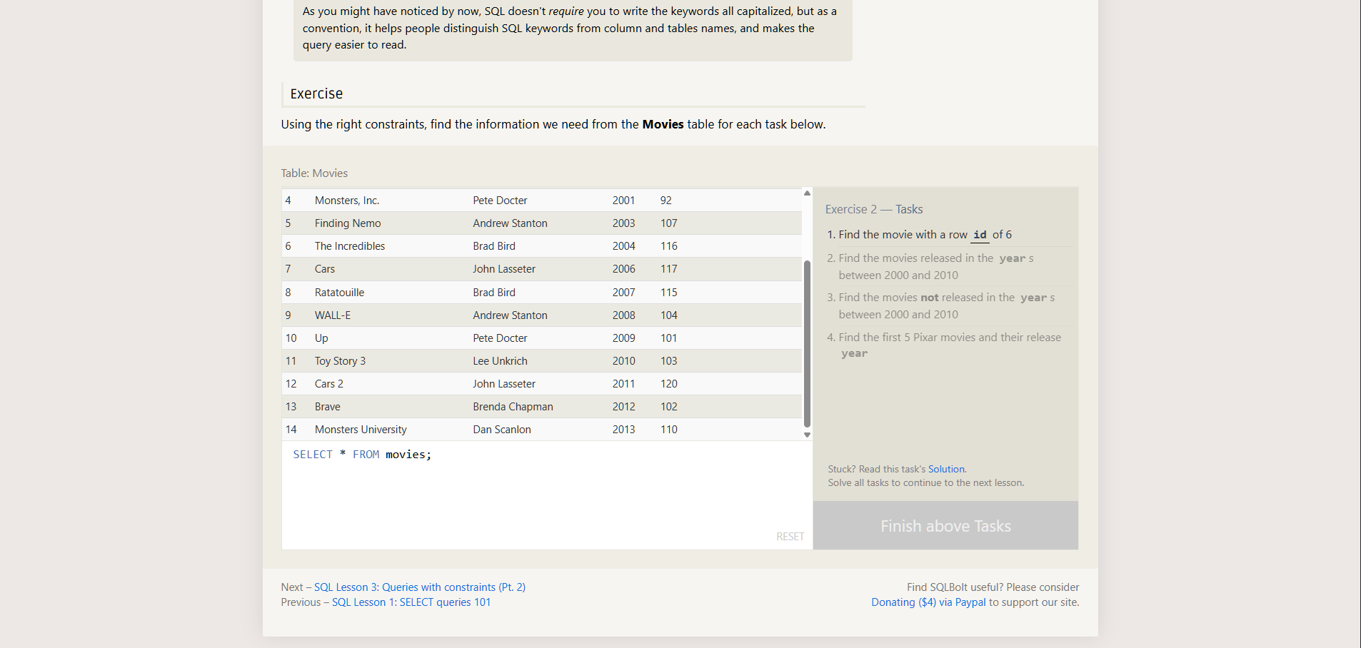

Task no 01:
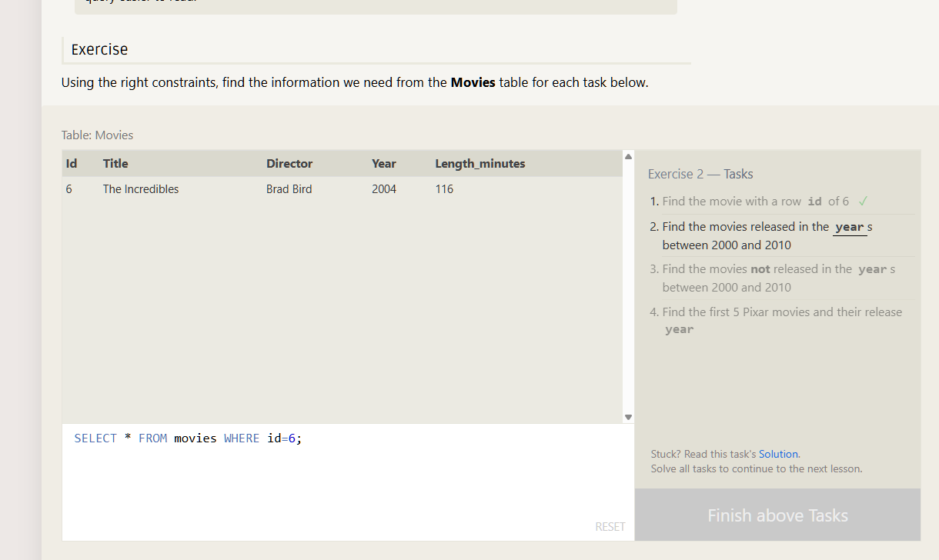

Task no 02:
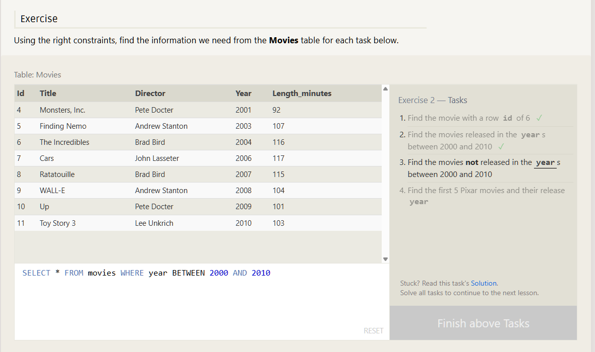

Task no 03:
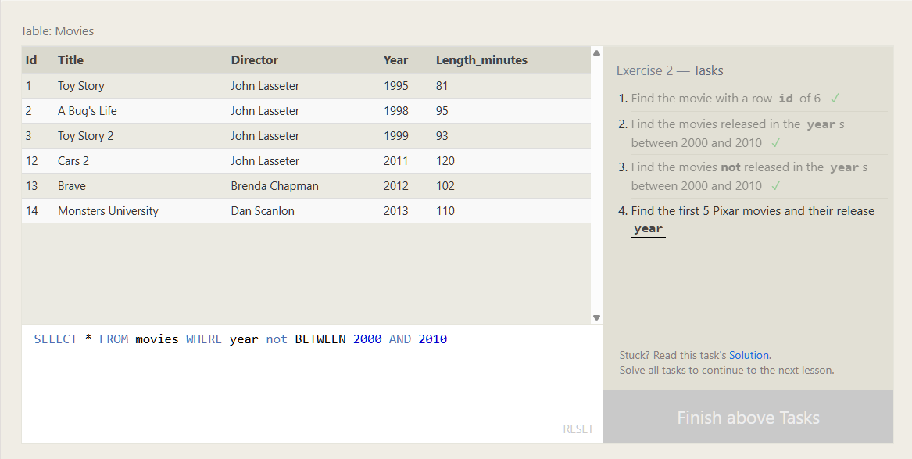

Task no 04:
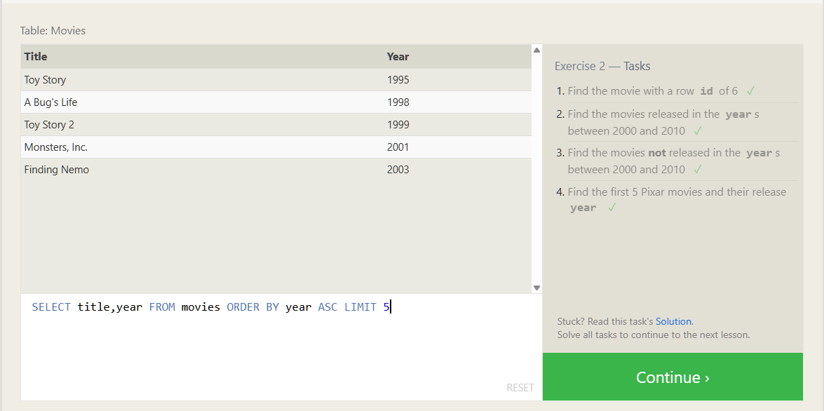

Question no 01:
Create a table called EMP with the following structure:
Name | Type
EMPNO | NUMBER(6)
ENAME | VARCHAR2(20)
JOB | VARCHAR2(10)
DEPTNO | NUMBER(3)
SAL | NUMBER(7,2)

Code:

CREATE TABLE emp (
empno NUMBER(6),
ename VARCHAR2(20) NOT NULL,
job VARCHAR2(10) NOT NULL,
deptno NUMBER(3),
sal NUMBER(7,2)
);

Output:
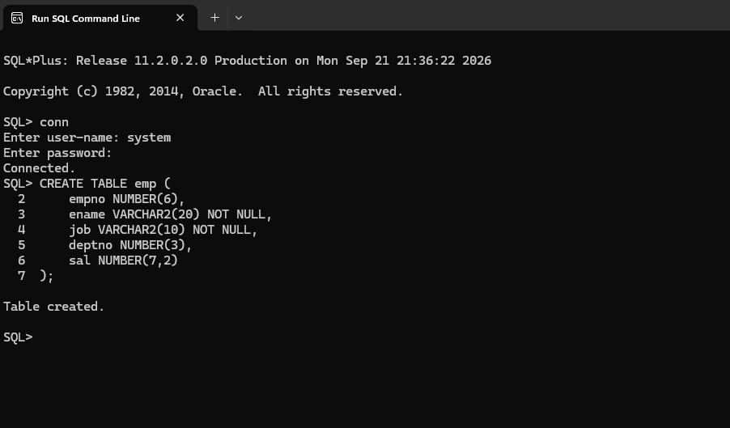

Question no 02:
Add a column EXPERIENCE to the EMP table. The EXPERIENCE column should be numeric and NULL values should be allowed.

Code:
ALTER TABLE emp
ADD (experience NUMBER(2));

Output:
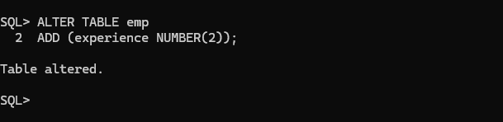

Question no 03:
Modify the column width of the JOB field of the EMP table.
Code:
ALTER TABLE emp
MODIFY (job VARCHAR2(12));
Output:
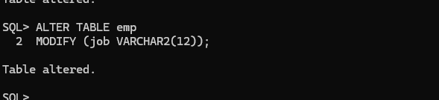

Question no 04:

Create a table called DEPARTMENT with the following structure:
Name | Type
DEPTNO | NUMBER(2)
DNAME | VARCHAR2(10)
LOC | VARCHAR2(10)
Make DEPTNO the Primary Key.

Code:
CREATE TABLE department (
deptno NUMBER(2),
dname VARCHAR2(10),
loc VARCHAR2(10),
CONSTRAINT dept_deptno_pk PRIMARY KEY (deptno)
);

Output:
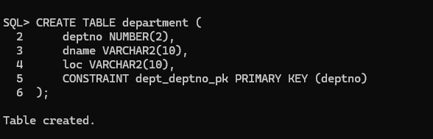
Question no 05:
Create a table called STAFF with the following structure:

Code:
CREATE TABLE staff (
empno NUMBER(6),
ename VARCHAR2(20),
job VARCHAR2(10),
deptno NUMBER(3),
sal NUMBER(7,2),
CONSTRAINT staff_deptno_fk
FOREIGN KEY (deptno)
REFERENCES department(deptno)
);
Output:
